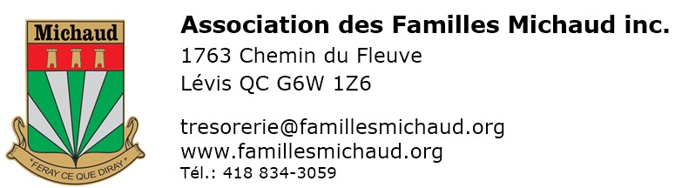APPLICATION FOR MEMBERSHIP

For new members registering between Octobre 1, 2023 and September 30, 2024
Three ways to pay for your subscription :
- The easiest by our site by our site https://famillesmichaud.org/en, section « Shopping online / Join us ». Visa, MasterCard or PayPal account OR
- Print, complete manually and mail this form with your check to Neuville OR
- Make an Interac transfer using the email tresorerie@famillesmichaud.org

Informations about the new member
Name |  |  |  |  |  |  |  |  | First name |  |  |  |  |  | Mr |  | Mrs
Address |  |  |  |  |  |  |  |  |  |  |  |  |  |  | Apartment number
City |  |  |  |  |  |  |  |  | Province, Country |  |  |  |  |  | Postal code
Phone number |  |  |  |  |  |  |  |  | E-mail  By providing your email, you automatically agree to subscribe to the association's e-newsletter.
Have you ever been a member of our association? |  |  |  |  |  |  | YES | NO |  | Member number  (if you know) :

SOME GENEALOGICAL INFORMATION (PLEASE ALSO COMPLETE THE FORM ATTACHED)
Retired? |  | YES NO |  |  |  |  |  | Profession / business
Birth (YYMMDD) |  |  |  |  |  | Place of  birth |  |  |  |  |  | Language of correspondence |  | FRENCH ENGLISH

CONTRIBUTION (CANADA) See https://famillesmichaud.org/en/achat-join-us to find out how long your subscription is valid (always on March 31, but the year depends on the month of your membership).
Regular  Member |  |  |  |  | $30  Until March 30, 2025  $80  Until March 30, 2027 |  |  | Limited time offer: Receive a birthday calendar valued at $ 20 with a 3-year membership fee. |  |  |  | Benefactor |  | 1 year ($60)  Until March 30, 2025
Life Member |  |  |  |  | ($375)  Paid in a single payment |  |  | Non transferable to husband or wife |  |  |  | Donor and benefactor: check if you do not want your name to appear in Brelan.

coNTRIBUTION (OUTSIDE CANADA)
For outside Canada, regardless of the country, please pay in U.S. dollars
Regular Member |  |  |  |  | US $35  Until March 30, 2025  US $95  Until March 30, 2027 |  |  | Limited time offer: Receive a birthday calendar valued at $ 20 with a 3-year membership fee. |  |  |  | Benefactor |  | US $70  Until March 30, 2025
Life Member |  |  |  |  | (US $400)  Paid in a single payment |  |  | Non transferable to husband or wife |  |  |  | Donor and benefactor: check if you do not want your name to appear in Brelan.
Return this completed form with your check to the order of Association des Familles Michaud Inc.,
to Association des familles Michaud, 1763 chemin du Fleuve, Lévis QC CANADA G6W 1Z6
SIGNATURE |  |  |  |  |  |  |  |  |  |  | Date

ACCESS TO ONLINE SERVICES (FREE)
Check the situation (s) corresponding to you
I refuse to have my name published in the association's journal.
I do not have an access code (or I do not remember) and I want access to the exclusive members section on www.famillesmichaud.org
I will be satisfied with the online version of the Brelan. Please do not send me hard copies (paper) by mail.
Note : The nominative information provided is considered confidential by the association, as required by Law 25 of Quebec.

